EMERALD KIDS INTERNATIONAL SCHOOL

FIRST TRIMESTER 2021/2022 SESSION SUMMATIVE TEST

NAME: ........................................ DATE: ...................

SUBJECT: COMPUTER SCIENCE. CLASS: GRADE 1

OBJECTIVE

Instruction: Answer all questions.

1. is an electronic device that processes data, stores data to give out information. (a) a clock (b) a calculator (c) a computer
2. The computer has main parts (a) 6 ()b 4 (c) 2
3. The television is a part of the computer ? True/false
4. The pat of the computer that shows pictures, videos and characters is called . ()a Television (b) Monitor (c) Radio
5. The part of the computer for typing characters into the computer is called . (a) the keyboard (b) the monitor (c) the system unit
6. What is the brain of the computer? (a) the mouse (b) the system unit (c) the monitor
7. All of the following are parts of the computer except (a) School bag (b) monitor (c) mouse
8. One of the following is not a part of a computer. (a) System unit

(b) keyboard (c) pen

1. A computer is a machine. True/false
2. A computer processes data. True/false

SUBJECTIVE

Match the following

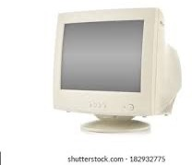1. **system unit**

# 2. **mouse**

3. 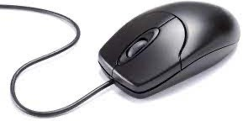 **monitor**

4. 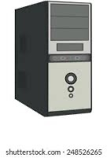 **keyboard**

5. Information can also be called